**REQUIREMENT CLARIFICATION QUESTIONS**

1. Should the sequence of the course types in the "Course Type" dropdown on the "Course Discount" page be specified in the same order as it is in the Requirement? (i.e. the first line should be Advanced, the second line should be Fundamental).

2․What kind of numbers can we fill in the "Discount" field? (i.e. can the discount be a unit number, decimal, etc.?)

3․ Is the number in the "Discount" field a percentage or not? If not, in what unit of measure is it presented?

4. How many courses can a non admin User buy with a discount? Is there a quantity limit, or is the discount valid for unlimited quantities?

5․Can we set different discount terms for Advanced and Fundamental courses, or should the written terms apply to both Advanced and Fundamental courses at the same time?

6․What does "*take into account admin configuration*" written in the requirement mean? What does it refer to? There is a need to clarify this phrase.

7. Should there be Minimum and Maximum limitations for “discount” and “course_count” fields?

8. There is no any information about required fields. Should “discount” and “course_count” fields be required fields?

9. When different admin users set the "discount" and "course_count" values at the same time, how does the QA engineer ensure that his settings remain the same during testing process?

10. What value should be selected by default for “Course Type” field? Or should the field be empty by default?

**SUGGESTIONS**

1. All field names should be written in the same font size, words should start with a capital letter and "Course Count" should be written without underline.

2․The distance between the “Course Type” and "discount" fields should be increased, because their locations are quite close to each other.

3․The "discount" and "course_count" fields are ridiculously large, they should be made smaller, and The "Course Type" field should have the same height as all other fields.

4․If, for example, the number written in the "discount" field is expressed as a percentage, then when a non-admin User receives a notification about a discount when purchasing the course, a percentage sign should also appear next to the amount of the discount (i. e., the text of the notification should be: "You have 50% discount. Discounted price displays.")․ Otherwise, the notification remains incomplete, because it is not clear to the non-admin User what measurement unit was used for the discount.

5. When purchasing the course, it is more appropriate to display both the discounted price of the course and also its non-discounted price.

6․On the "Change Discount" page, next to the word "discount" should be specifed the measurement unit. For example, if it is expressed as a percentage, indicate the percent sign/word, or if it is in a different measurement unit, indicate the name of the given measurement unit.

7․The "discount" and "course_count" fields should be resetted to default (i.e. be empty) after admin user set discount values and click “Change Discount” button.

8․When a non-admin User enters the "Courses" section to purchase a course, there should be some kind of notification related to the discounts, so that the non-admin User knows how many courses the discount system will run after purchasing. Otherwise, a non-admin User cannot in any way be notified of discounts before making a purchase.

9. It would be better to have a multiselect option for "Course Type" dropdown, in case, when the admin user wants to set the same discount values for both types of courses.

10. It would be better to have asterisk (*) for required fields. And if the user forgot to set values for the fields the system highlights them somehow.

**BUG REPORT**

* ***URL:*** https://qwallity-exam.onrender.com

***Operation System:*** Windows 10 Pro

***Browser:*** Google Chrome

***Browser Version:*** 108.0.5359.94

***Steps to Reproduce:***

1. Enter valid email (manualtesting09152022@gmail.com) and security code (219659750)

2. Press "Send" button

3. Click "Login" button

4. Enter admin valid username (Anna22d) and password (anna2211) and click "Log In" button and enter admin`s profile

5. Click "Change Discount" button

6. Input letters in both "discount" and "course_count" fields (abcd, ifg)

7. Click "Change Discount" button

8. Input symbols in both "discount" and "course_count" fields ($$$, %%)

9. Click "Change Discount" button

***Expected Result:*** when clicking "Change Discount" button, a notification should appear for "discount" and "course_count" fields, stating that only numeric characters are allowed to be entered

***Actual Result:*** "Discount is changed" notification is appears

***Screenshot:*** attached

***Severity:*** medium

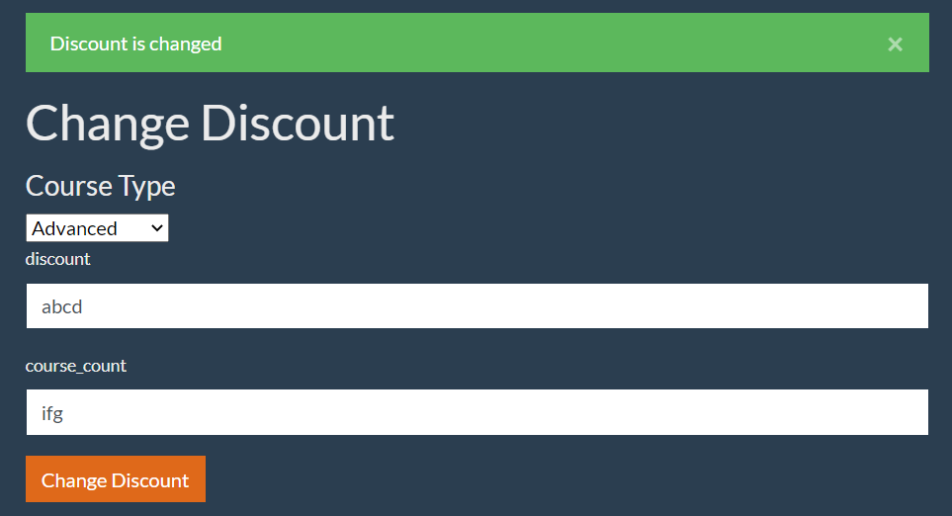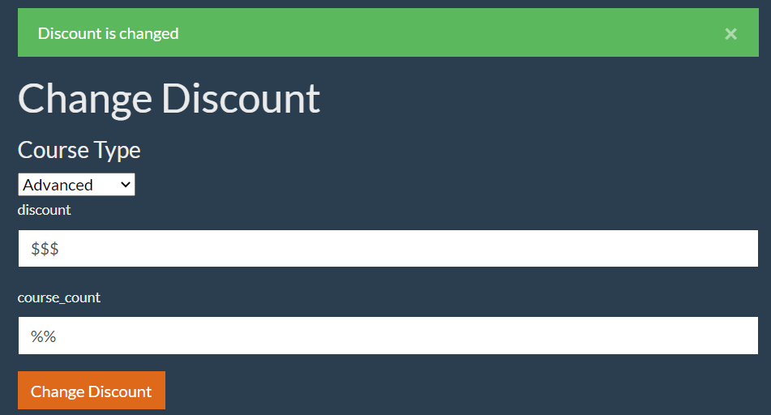

* ***URL:*** https://qwallity-exam.onrender.com

***Operation System:*** Windows 10 Pro

***Browser:*** Google Chrome

***Browser Version:*** 108.0.5359.94

***Steps to Reproduce:***

1. Enter valid email (manualtesting09152022@gmail.com) and security code (219659750)

2. Press "Send" button

3. Click "Login" button

4. Enter admin valid username (Anna22d) and password (anna2211) and click "Log In" button and enter admin`s profile

5. Click "Change Discount" button

6. Input valid numerical numbers in both "discount" and "course_count" fields (50, 2)

7. Click "Change Discount" button

***Expected Result:*** "Discount changes" notification should be appeared

***Actual Result:*** "Discount is changed" notification appears

***Screenshot:*** attached

***Severity:*** low

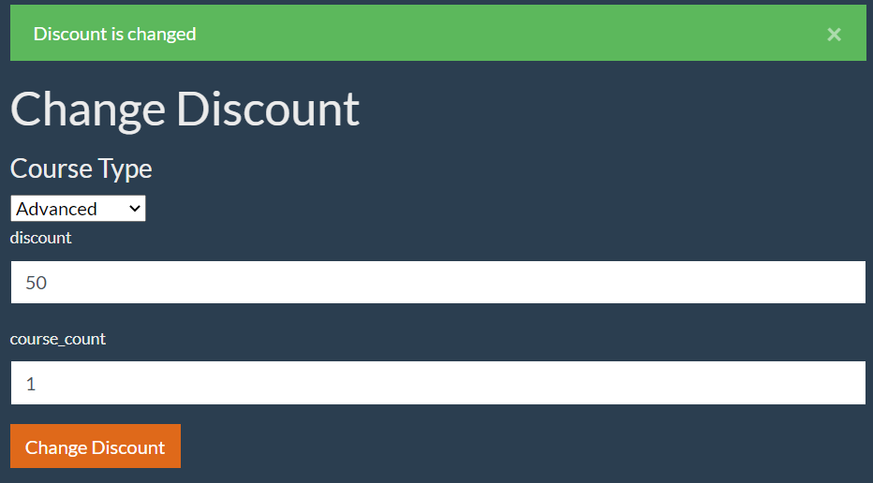

* ***URL:*** https://qwallity-exam.onrender.com

***Operation System:*** Windows 10 Pro

***Browser:*** Google Chrome

***Browser Version:*** 108.0.5359.94

***Steps to Reproduce:***

1. Enter valid email (manualtesting09152022@gmail.com) and security code (219659750)

2. Press "Send" button

3. Click "Login" button

4. Enter admin valid username (Anna22d) and password (anna2211) and click "Log In" button and enter admin`s profile

5. Click "Change Discount" button

6. Click "Change Discount" button in "Change Discount" page

***Expected Result:*** "Enter data in required fields" or similar notification should appear

***Actual Result:*** "Discount is changed" notification appears

***Screenshot:*** attached

***Severity:*** critical

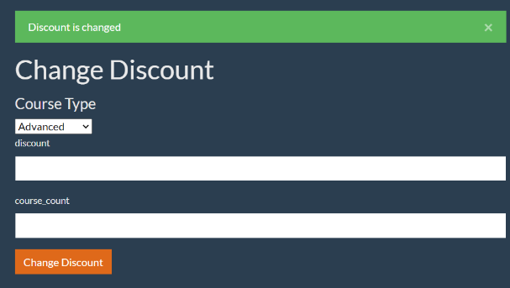

* ***URL:*** https://qwallity-exam.onrender.com

***Operation System:*** Windows 10 Pro

***Browser:*** Google Chrome

***Browser Version:*** 108.0.5359.94

***Steps to Reproduce:***

1. Enter valid email (manualtesting09152022@gmail.com) and security code (219659750)

2. Press "Send" button

3. Click "Login" button

4. Enter admin valid username (Anna22d) and password (anna2211) and click "Log In" button and enter admin`s profile

5. Click "Change Discount" button

6. Choose from "Course Type" field Advances course by defalut

7. Input valid numerical numbers in both "discount" and "course_count" fields (50, 2) and Click "Change Discount" button

8. Choose from "Course Type" field Fundamental course

9. Input valid numerical numbers in both "discount" and "course_count" fields (50, 1) and Click "Change Discount" button

***Expected Result:*** System allows admin user to set different values for Fundamental and Advanced courses in "Change Discount" page

***Actual Result:*** In the case of Fundamental course, when clicking "Change Discount" button, Advanced course appears in "Course Type" field

***Screenshot:*** -

***Severity:*** critical